POST-CONFERENCE BROCHURE
VII EDITION OF THE CONFERENCE
“THE BEST WAY TO PREDICT THE FUTURE IS TO CREATE IT”
Biotechnology as an engine of innovation – Polish-American cooperation

October 24th, 2022
Willard InterContinental Washington D.C. Hotel

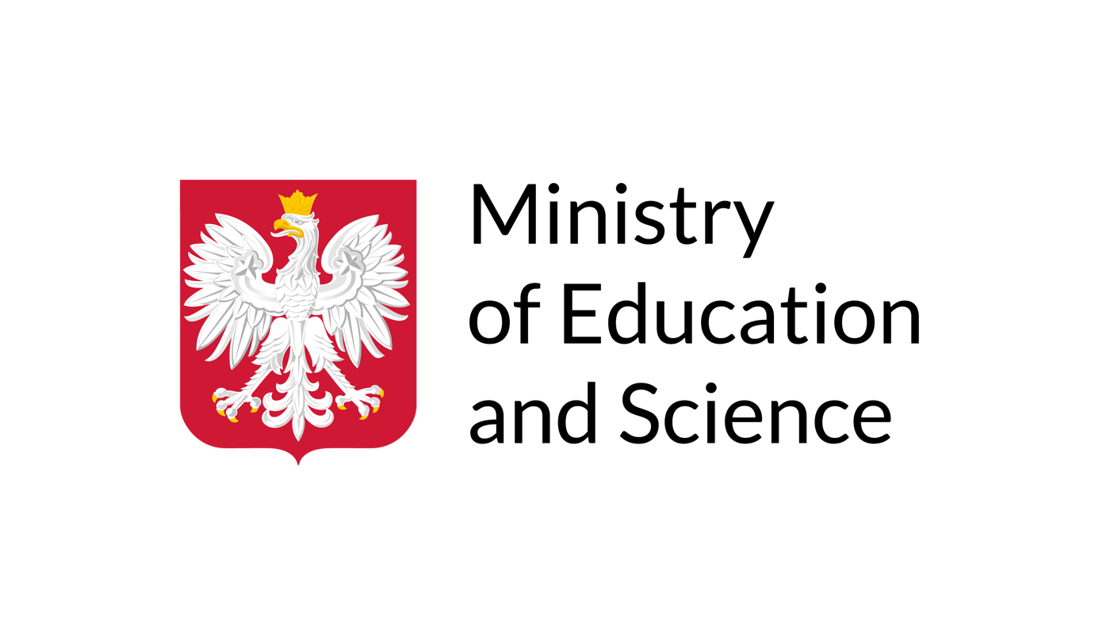
The conference was financed by the Ministry
of Education and Science under the „Excellent Science” program, module „Support for scientific conferences”

CONFERENCE AGENDA

10:00 AM - 10:30 AM REGISTRATION
10:30 AM - 11:00 AM OPENING OF THE CONFERENCE
OPENING REMARKS
- Małgorzata Bogusz, President of the Kulski Foundation for Polish-American relations, President of the Institute for Social Policy Development, Member of the European Economic and Social Committee, Poland
HONORARY ADDRESS
- Adam Niedzielski, PhD, Minister of Health, Poland
- Prof. Przemysław Czarnek, Minister of Education and Science, Poland (pre-recorded speech)

11:00 AM - 12:30 PM ROUNDTABLE I: Polish-American cooperation in public-private partnership in the field of biotechnology
Moderators:
Henry F. Homans, Vice-president of the American-Central European Business Association (ACEBA), USA
Jakub Gierczyński, PhD, MD, Expert of the Institute for Social Policy Development, Poland
Participants:
- Adam Niedzielski, PhD, Minister of Health, Poland
- Prof. Radosław Sierpiński, MD, President of the Medical Research Agency, Prime Minister’s Plenipotentiary for the Development of the Biotechnology Sector and Poland's Independence in Blood Derivative Products, Poland
- Prof. Łukasz Szumowski, MD, Director of the National Institute of Cardiology, Minister of Health 2018-2020, Poland
- Prof. Piotr Ponikowski, MD, Rector of the Medical University of Wroclaw, Poland
- Prof. Maria Siemionow, MD, Director of Microsurgery Research at the University of Illinois Chicago, USA
- Prof. Piotr Rutkowski, MD, President of the Polish Oncology Society, Poland
- Paweł Kaliński, PhD, MD, Roswell Park Comprehensive Cancer Center, USA
- Anna Korzan, MD, President of the Polish-American Health Association (PAHA), USA
- Marcin Czarniecki, MD, Assistant Professor, Advanced Radiology, University of Maryland Medical System, USA
- Vittorio Gallo, PhD, MD, Interim Chief Academic Officer, Children’s National Hospital Interim Director, Children's National Research Institute, USA
- Herlys Gianelli, Associate Vice-President, Global Vaccines Public Policy & Partnerships at Merck & Co., Inc., USA
- Dimitri Gitas, Managing Director at MSD Poland
- Michael Soldan, CEO Polpharma Biologics Group
- Piotr Korycki, President of the Management Board, Managing Director Polpharma Biologics S.A.
- Stanisław Pisarski, President of the Factor Consulting, Poland
- Brian Toohey, Vice-President of Global Government Affairs and Public Policy, Illumina, USA

12:30 PM - 12:40 PM SIGNING OF MEMORANDA OF UNDERSTANDING

12:40 PM - 12:45 PM A CEREMONY OF HANDING OVER A NOMINATION OF PROF. MARIA SIEMIONOW TO THE COUNCIL OF THE MEDICAL RESEARCH AGENCY

12:45 PM - 1:15 PM NETWORKING LUNCH

1:15 PM - 2:45 PM ROUNDTABLE II: Biotechnology as a strategic sector in economic and security dimensions
Moderators:
Henry F. Homans, Vice-president of the American-Central European Business Association (ACEBA), USA
Jakub Gierczyński, PhD, MD, Expert of the Institute for Social Policy Development, Poland

Participants:
- Marcin Martyniak, Undersecretary of the Ministry of Health, Poland
- Prof. Radosław Sierpiński, MD, President of the Medical Research Agency, Prime Minister’s Plenipotentiary for the Development of the Biotechnology Sector and Poland's Independence in Blood Derivative Products, Poland
- Grzegorz Cessak, PhD, President of the Office for Registration of Medicinal Products, Medical Devices and Biocidal Products, Poland
- Prof. Marcin Moniuszko, MD, Vice-Rector for Science and Development at the Medical University of Bialystok, Poland
- Marek Migdał, PhD, MD, Director of the Children's Memorial Health Institute in Warsaw, Poland
- Piotr Trąbiński, Executive Director of the International Monetary Fund, Poland
- Prof. Waldemar Priebe, MD, The University of Texas MD Anderson Cancer Center, USA
- Prof. Brygida Kwiatkowska, MD, National Consultant in Rheumatology, Poland
- Prof. Jarosław Czubak, MD, National Consultant in Orthopedics and Traumatology of the Musculoskeletal System, Poland
- George W. Handy, President of the Supervisory Board at the Alliance for Innovation, USA
- ​​ Hilary Stiss, Director of International Affairs and Program Director of the International Council of Biotechnology Associations at the Biotechnology Innovation Organization (BIO), USA
- Magdalena Starban, MD, Member of the Board of Directors at the Polish-American Health Association (PAHA), USA
- Dimitri Gitas, Managing Director at MSD Poland
- Michael Soldan, CEO Polpharma Biologics Group
- Piotr Korycki, President of the Management Board, Managing Director Polpharma Biologics S.A.

2:45 PM SUMMARY AND CONCLUSION OF THE CONFERENCE
Henry F. Homans, Vice-president of the American-Central European Business Association (ACEBA), USA
Jakub Gierczyński, PhD, MD, Expert of the Institute for Social Policy Development, Poland

DISCUSSION

The crises we have faced in recent years, such as the COVID-19 pandemic, have shown us the importance of dynamic scientific development in strategic sectors for countries. One of the key, and at the same time dynamically developing areas, is the biotechnology sector. It is recognized by many countries, which are systemically supporting companies and engaging in the development of innovative solutions. The United States is undoubtedly a leader in the development of biotechnology in the world. Among other things, through appropriate legal solutions that favor the commercialization of innovations, they create space for the development of projects in the private sector. The exchange of experts' experience in this area will be extremely valuable for Poland, which aspires to the role of the leader of Central and Eastern Europe in the field of biotechnology.

During two roundtable discussions, participants discussed Polish-American cooperation in public-private partnerships and the strategic role of biotechnology for the economy and security.

The pandemic and the war in Ukraine have shown that one of the key challenges is to make drug production in Europe independent of India and China, Health Minister Adam Niedzielski told PAP. The minister took part in a conference on Polish-American cooperation in biotechnology, held in Washington. As he assessed, cooperation with the US is important for fulfilling Polish ambitions to become a regional leader in the field of biotechnology. "We should be independent in the production of medicines in Europe, thus becoming independent of production in India or China. First the pandemic and now the war in Ukraine have shown that this is a key challenge," Niedzielski said.

Niedzielski cited the issue of independence from Asia as one of the three biggest challenges and lessons from the pandemic. In doing so, he stressed the importance of countries' resilience to crises. "When we experience crises - and we are still experiencing this during the war in Ukraine - we find that we don't have certain ingredients used to produce medicines," - Niedzielski said. "Covid-19 showed that those supply chains that were based on manufacturers in India and China were not a model that worked well. The bottom line is that we should work together to make sure our markets are fully secured," he added.

Among other key lessons from the pandemic, Niedzielski listed the rapidly aging population in the face of increasing demand for medical care and shortages of health care personnel. Investment in biotechnology innovation is the key to overcoming this problem, he assessed. He added that Poland "has already begun to march down this path" by creating the Medical Research Agency. "We have more and more elderly people in society, multi-disease will become more and more common, and we need diagnostics and other services more and more. However, the daily reality is that we don't have enough specialists," the minister said. Innovation could help, for example, through the development of a telecare system or health monitoring devices, he explained. The minister also said that Covid-19 demonstrated the crucial importance of public-private sector cooperation, pointing out that it was only through such cooperation that it was possible to "cut through the disaster," developing vaccines at a tremendous pace and scale.

The Minister of Education Przemyslaw Czarnek, speaking from Warsaw, said in turn that Poland intends to become a leader in our region in the field of biotechnology. "We are convinced that it is research in this area that can drive Polish innovation," he said. He noted that important to this ambition will be cooperation with the US and the adaptation of global best practices and models in this discipline.

"We already have such a dominant position in the region when it comes to pharmaceutical production. If we look more broadly, Poland has the sixth position in terms of pharmaceuticals sold. So this is a good starting point to respond to some of the lessons that come out of Covid-19, especially in terms of independence," Niedzielski told PAP.
The exchange of experiences with the US was one of the main topics of discussion at the conference held at the Willard Hotel in Washington among Polish and American specialists from scientific centers in both countries, representatives of authorities and private companies. Experts pointed out, among other things, the need to streamline and digitize research, better commercialize it and create an environment friendly to innovative research. Former Health Minister Prof. Lukasz Szumowski said at the same time that cooperation with the US must be mutually beneficial, and Poland has much to offer America. In doing so, he mentioned the possibility of exchanging clinical trial data with the US.

Speakers also spoke about the importance of biotechnology to the economy and security. They advocated, among other things, the need for more money to invest in research and science, both in the public and private sectors. In doing so, they pointed out that in Europe they are at a much lower level than in the US.

During the conference, Minister Niedzielski also presented the appointment of Professor Maria Siemionow to the Council of the Medical Research Agency. Siemionow is a world-renowned surgeon working at the University of Illinois at Chicago, who became famous for, among other things, performing the first successful face transplant operation in the US. In an interview with PAP, Siemionow encouraged Polish medics and scientists to train in the US. "Those scientists who come here almost all come back, so they contribute to the development of science in Poland. They learn discipline here, hard work. So it's a good investment for both sides," she said.

The Kulski Foundation
for Polish-American relations
2022

